St. Francis of Assisi, Isleworth
www.stfrancis-isleworth.org

Pentecost
Sunday May 21st, 2020

Sadly the church building is currently closed in the light of the COVID-19 crisis
Sunday Eucharist each Sunday at 11am on Facebook Live
www.facebook.com/stfrancisisleworth
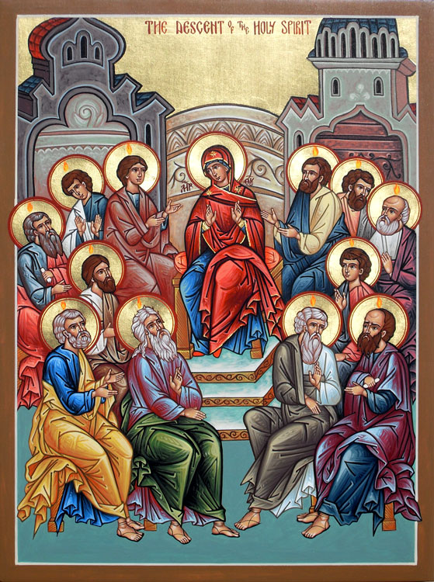

Today we recall how the Holy Spirit came to the disciples, empowering them for God’s mission to the world. We in our time pray, too, ‘Come, Holy Spirit.’

For your prayers

For the coming of the Holy Spirit
For the wider Church especially Justin our archbishop, Sarah our bishop, and Graham our area bishop
For the needs of the world especially all affected by the Coronavirus outbreak; for the UK government, and devolved governments; for health workers; for all caring for the vulnerable
For our congregation, although we cannot meet together, still one in prayer, one in the Spirit
For the sick and the suffering
For the departed especially those whom we have known and loved; for people recently bereaved

Collect

God, who as at this time
taught the hearts of your faithful people
by sending to them the light of your Holy Spirit:
grant us by the same Spirit
to have a right judgement in all things
and evermore to rejoice in his holy comfort;
through the merits of Christ Jesus our Saviour,
who is alive and reigns with you,
in the unity of the Holy Spirit,
one God, now and for ever.

First Reading Acts 2.1-13

When the day of Pentecost had come, they were all together in one place. And suddenly from heaven there came a sound like the rush of a violent wind, and it filled the entire house where they were sitting. Divided tongues, as of fire, appeared among them, and a tongue rested on each of them. All of them were filled with the Holy Spirit and began to speak in other languages, as the Spirit gave them ability. Now there were devout Jews from every nation under heaven living in Jerusalem. And at this sound the crowd gathered and was bewildered, because each one heard them speaking in the native language of each. Amazed and astonished, they asked, ‘Are not all these who are speaking Galileans? And how is it that we hear, each of us, in our own native language? Parthians, Medes, Elamites, and residents of Mesopotamia, Judea and Cappadocia, Pontus and Asia, Phrygia and Pamphylia, Egypt and the parts of Libya belonging to Cyrene, and visitors from Rome, both Jews and proselytes, Cretans and Arabs – in our own languages we hear them speaking about God’s deeds of power.’ All were amazed and perplexed, saying to one another, ‘What does this mean?’ But others sneered and said, ‘They are filled with new wine.’

Responsorial Psalm Psalm 104.1, 24, 29-31, 34

R Send forth your Spirit, O Lord,
and renew the face of the earth.

Bless the Lord, my soul!
Lord God, how great you are,
How many are your works, O Lord!
The earth is full of your riches. R.

You take back your spirit, they die,
returning to the dust from which they came.
You send forth your spirit, they are created;
and you renew the face of the earth. R.

May the glory of the Lord last for ever!
May the Lord rejoice in his works!
May my thoughts be pleasing to him.
I find my joy in the Lord. R.

Second Reading 1 Corinthians 12.3b-13

I want you to understand that no one speaking by the Spirit of God ever says ‘Let Jesus be cursed!’ and no one can say ‘Jesus is Lord’ except by the Holy Spirit.
Now there are varieties of gifts, but the same Spirit; and there are varieties of services, but the same Lord; and there are varieties of activities, but it is the same God who activates all of them in everyone. To each is given the manifestation of the Spirit for the common good. To one is given through the Spirit the utterance of wisdom, and to another the utterance of knowledge according to the same Spirit, to another faith by the same Spirit, to another gifts of healing by the one Spirit, to another the working of miracles, to another prophecy, to another the discernment of spirits, to another various kinds of tongues, to another the interpretation of tongues. All these are activated by one and the same Spirit, who allots to each one individually just as the Spirit chooses. For just as the body is one and has many members, and all the members of the body, though many, are one body, so it is with Christ. For in the one Spirit we were all baptized into one body—Jews or Greeks, slaves or free—and we were all made to drink of one Spirit.

Gospel Reading John 20.19-23

When it was evening on that day, the first day of the week, and the doors of the house where the disciples had met were locked for fear of the Jews, Jesus came and stood among his disciple and said, ‘Peace be with you.’ After he said this, he showed them his hands and his side. Then the disciples rejoiced when they saw the Lord. Jesus said to them again, ‘Peace be with you. As the Father has sent me, so I send you.’ When he had said this, he breathed on them and said to them, ‘Receive the Holy Spirit. If you forgive the sins of any, they are forgiven them; if you retain the sins of any, they are retained.’

Litany of prayer for Pentecost

We pray for God to fill us with his Spirit.
Generous God,
we thank you for the power of your Holy Spirit.
We ask that we may be strengthened to serve you better.
Lord, come to bless us
All and fill us with your Spirit.

We thank you for the wisdom of your Holy Spirit.
We ask you to make us wise to understand your will.
Lord, come to bless us
All and fill us with your Spirit.

We thank you for the peace of your Holy Spirit.
We ask you to keep us confident of your love wherever you call us.
Lord, come to bless us
All and fill us with your Spirit.

We thank you for the healing of your Holy Spirit.
We ask you to bring reconciliation and wholeness
where there is division, sickness and sorrow.
Lord, come to bless us
All and fill us with your Spirit.

We thank you for the gifts of your Holy Spirit.
We ask you to equip us for the work which you have given us.
Lord, come to bless us
All and fill us with your Spirit.

We thank you for the fruit of your Holy Spirit.
We ask you to reveal in our lives the love of Jesus.
Lord, come to bless us
All and fill us with your Spirit.

We thank you for the breath of your Holy Spirit,
given us by the risen Lord.
We ask you to keep the whole Church, living and departed,
in the joy of eternal life.
Lord, come to bless us
All and fill us with your Spirit.

Generous God,
you sent your Holy Spirit upon your Messiah at the river Jordan,
and upon the disciples in the upper room:
in your mercy fill us with your Spirit,
All hear our prayer,
and make us one in heart and mind
to serve you with joy for ever. Amen.

Prayers for the current time of crisis

Let us pray to God,
who alone makes us dwell in safety:
For all who are affected by coronavirus,
through illness or isolation or anxiety,
that they may find relief and recovery:
Lord, hear us,
Lord, graciously hear us.
For those who are guiding our nation at this time,
and shaping national policies,
that they may make wise decisions:
Lord, hear us,
Lord, graciously hear us.
For doctors, nurses and medical researchers,
that through their skill and insights
many will be restored to health:
Lord, hear us,
Lord, graciously hear us.
For the vulnerable and the fearful,
for the gravely ill and the dying,
that they may know your comfort and peace:
Lord, hear us,
Lord, graciously hear us.
We commend ourselves, and all for whom we pray,
to the mercy and protection of God.

Merciful Father,
accept these prayers
for the sake of your Son,
our Saviour Jesus Christ.
Amen.

